OBJECT ORIENTED ANALYSIS AND DESIGN

NAME: T.Poojitha REG NO :192011253

USECASE DIAGRAM:s

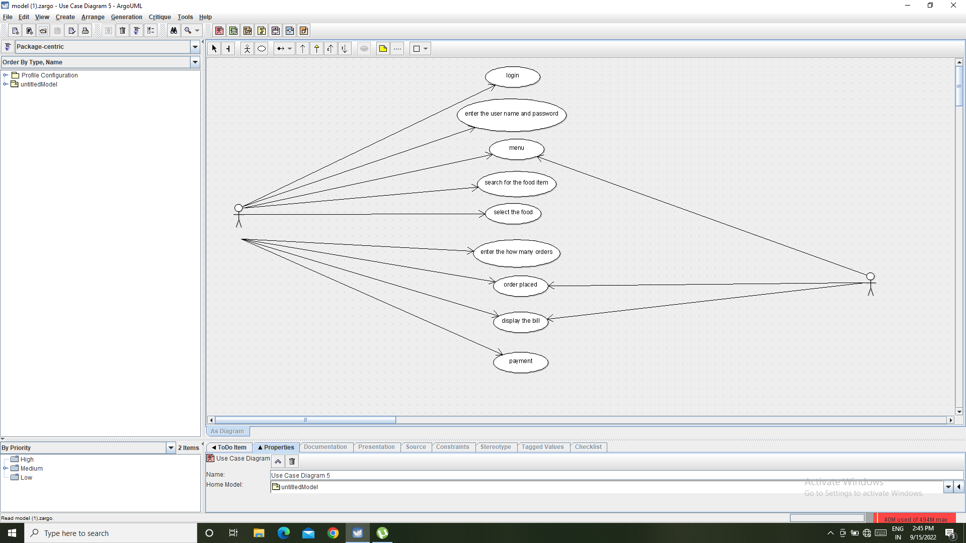

Class diagram:

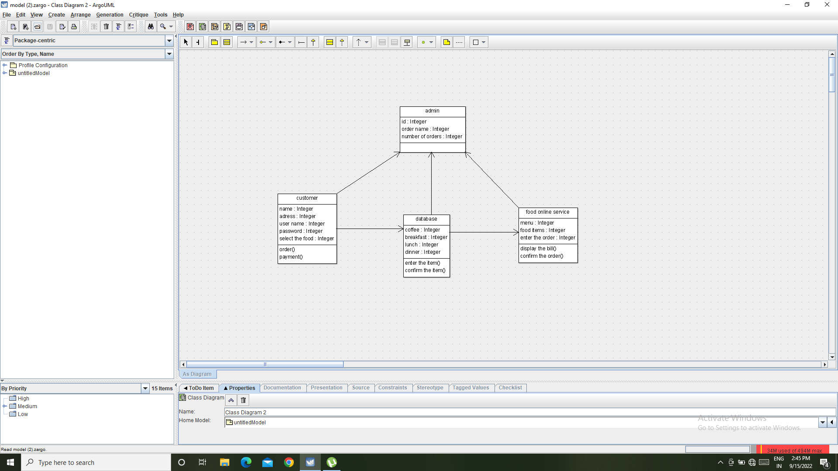

public class admin {

public Integer id;

public Integer order name;

public Integer number of orders;

}

SEQUENCE DIAGRAM :

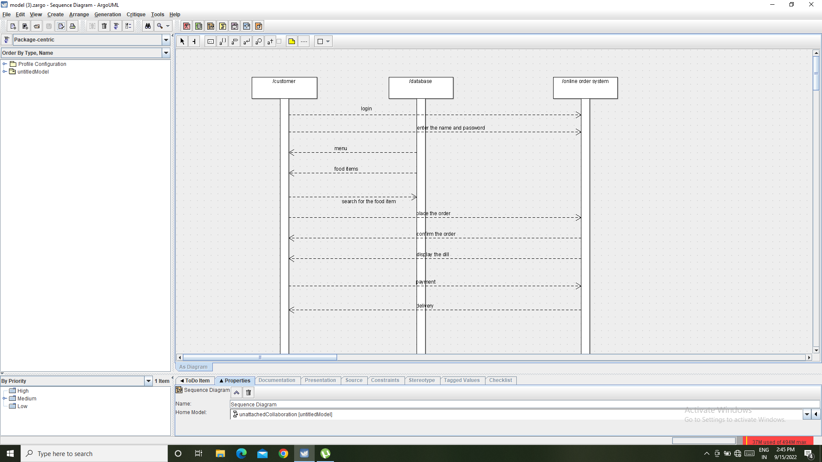

ACTIVITY DIAGRAM:

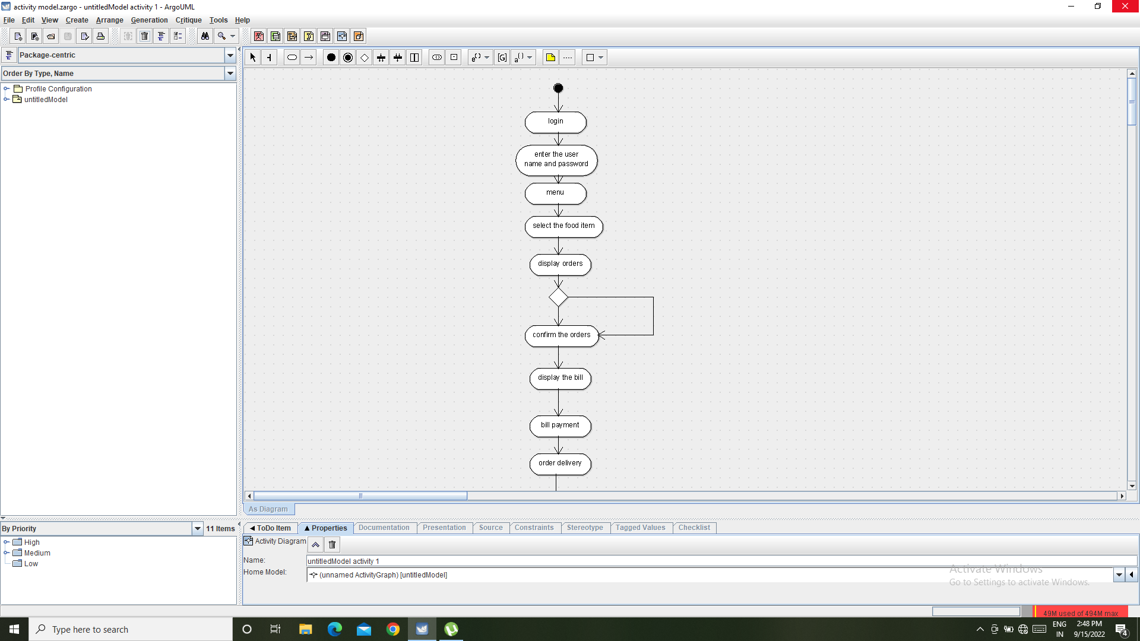

COLLABRATION DIAGRAM:

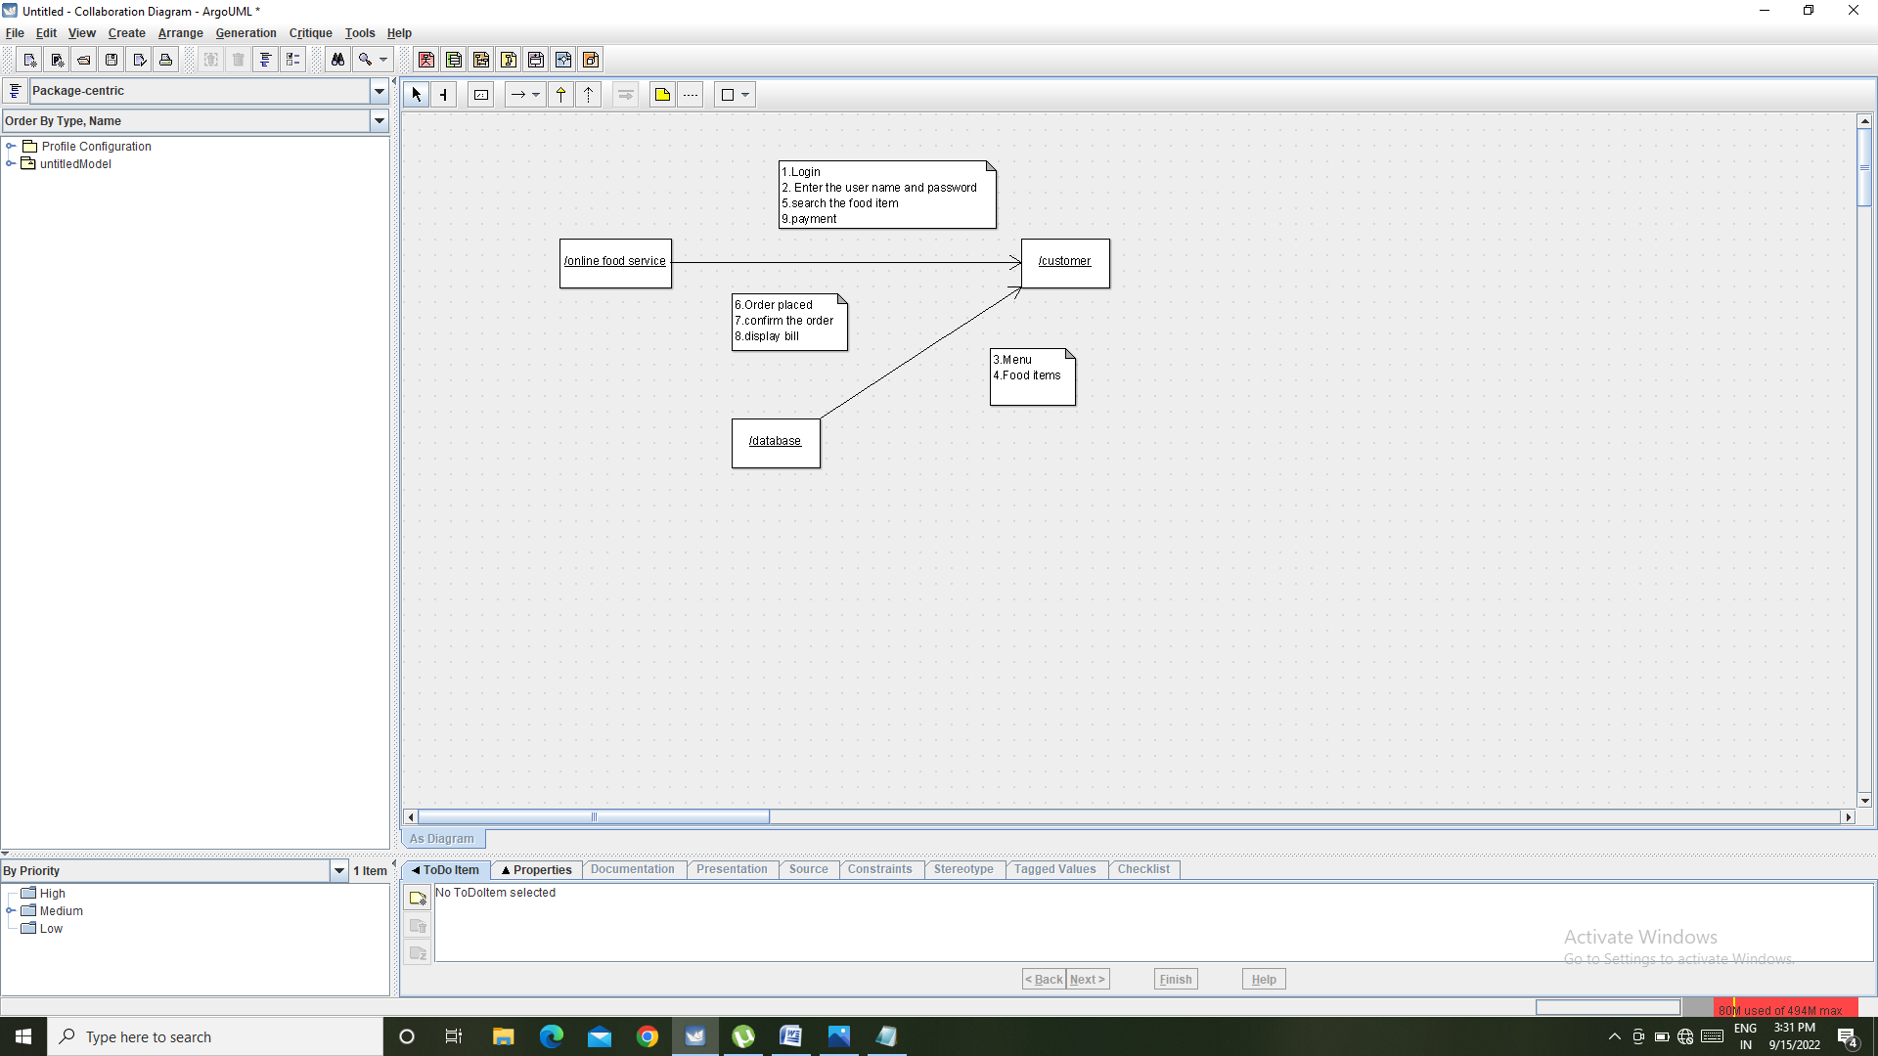

START CHART DIAGRAM:

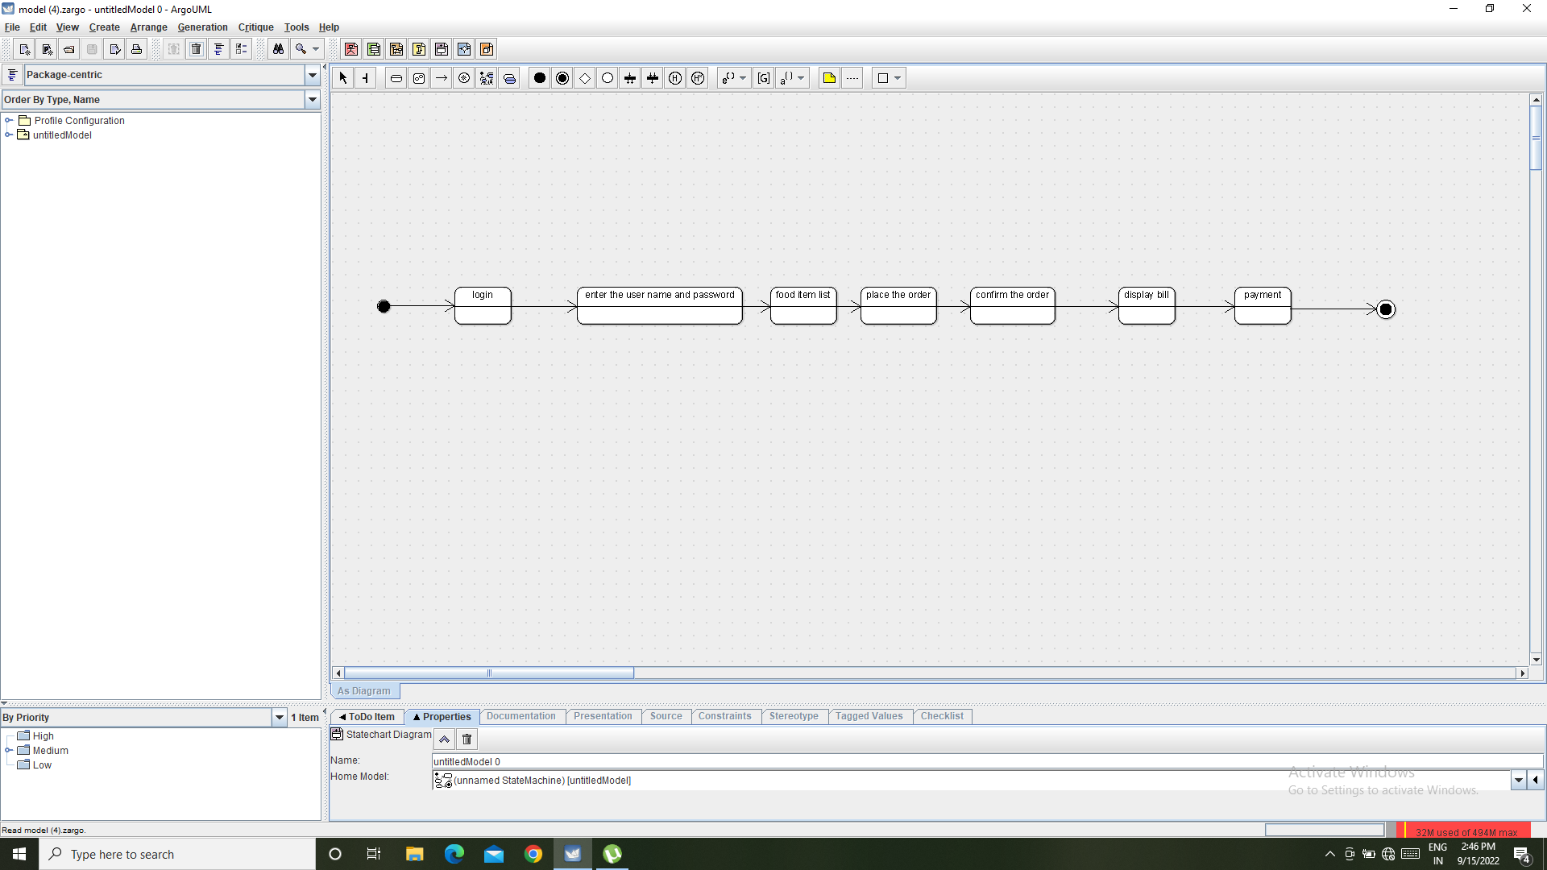

COMPONENT DIAGRAM:

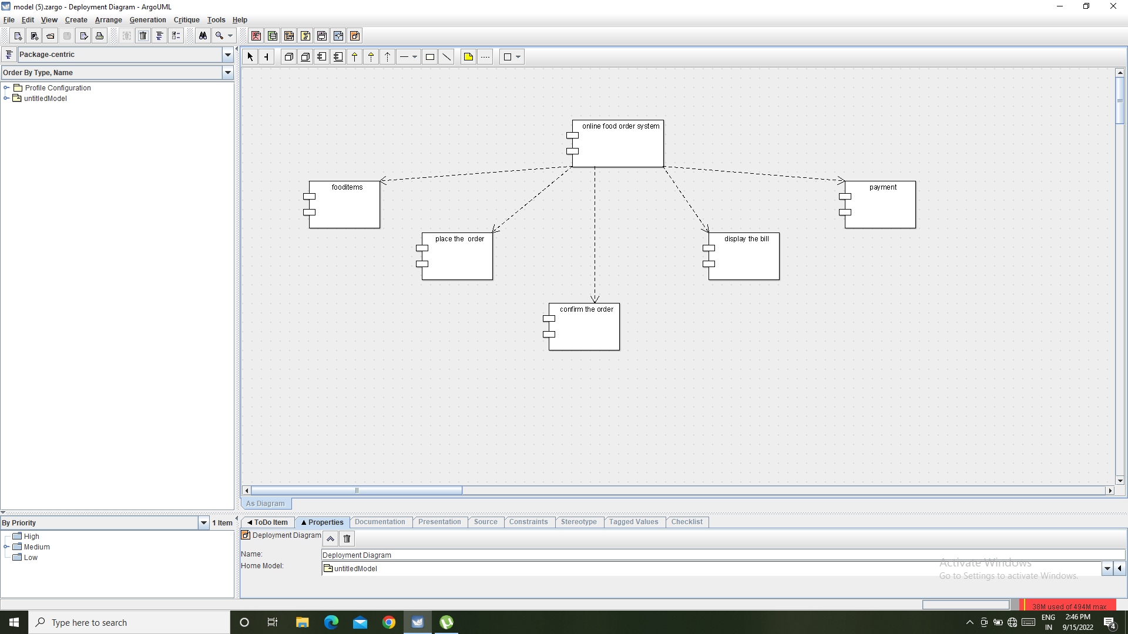

DEPLOYMENT DIAGRAM:

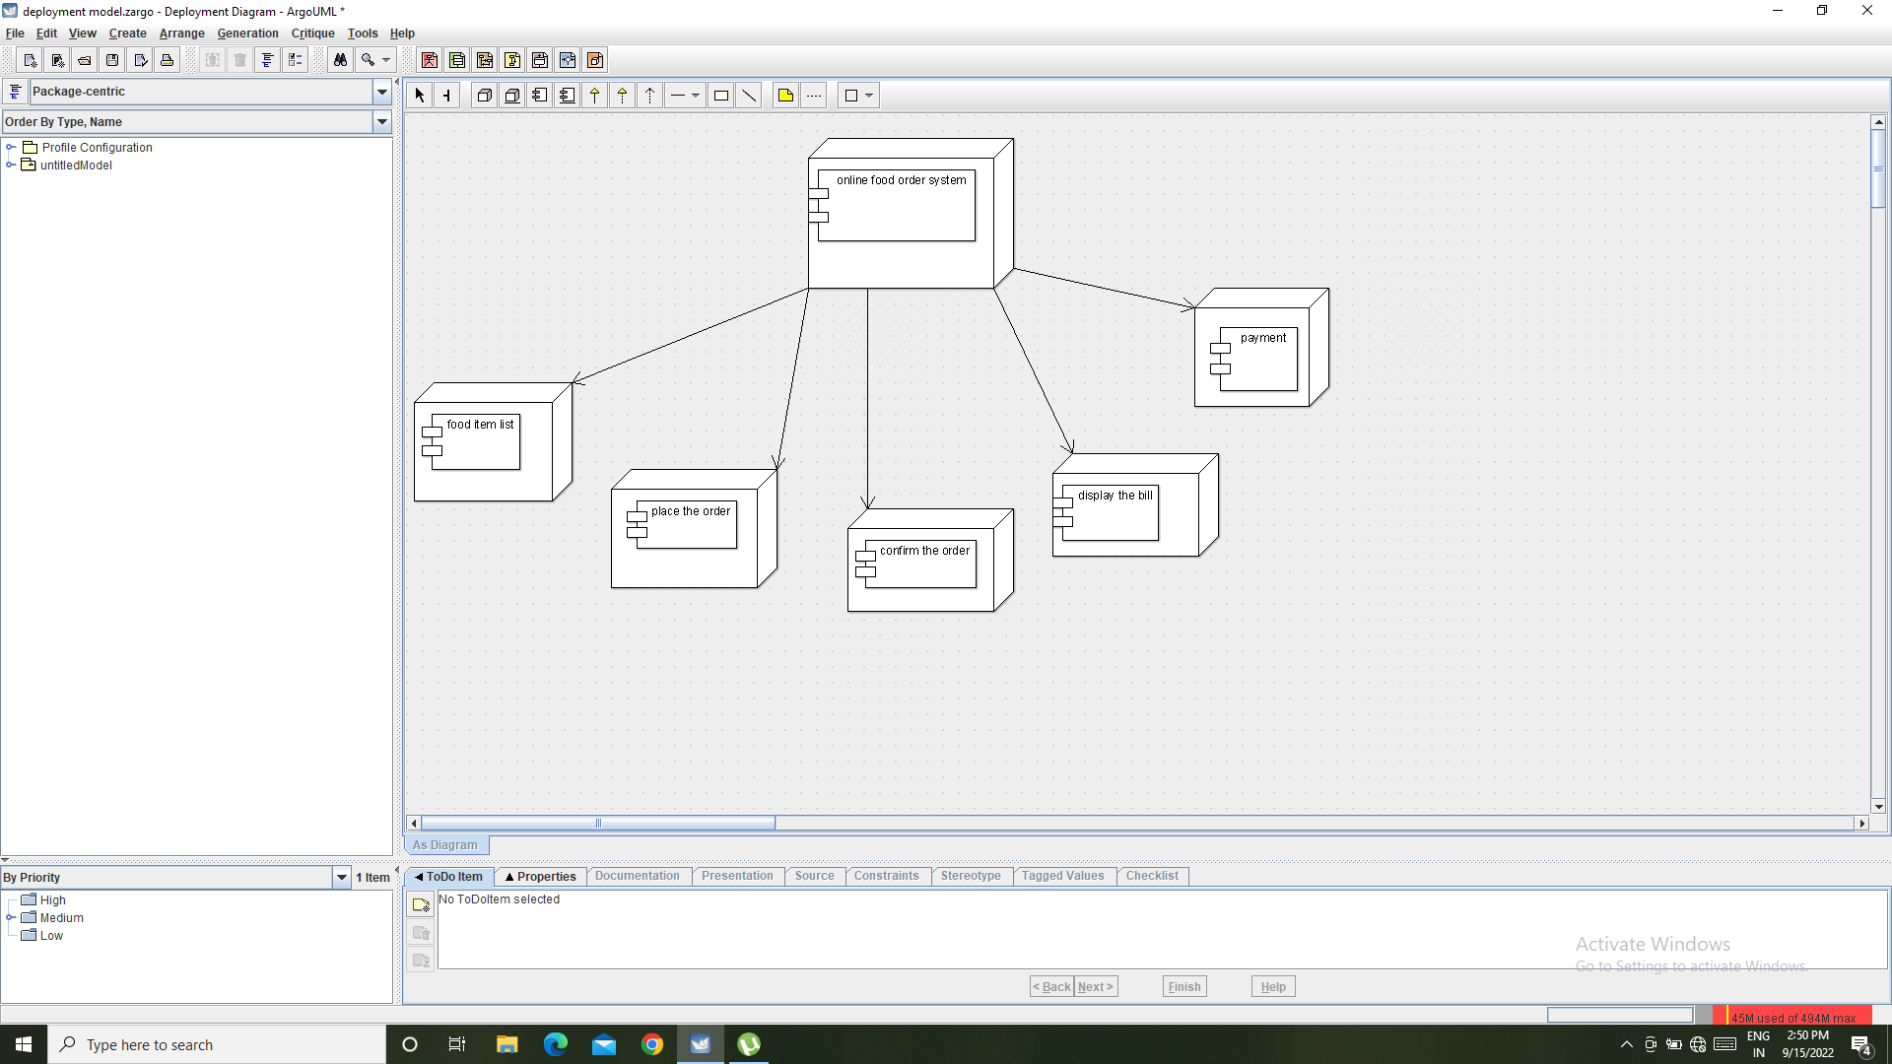

PACKAGE DIAGRAM:

